### 1. Welcome-to-the-Exams

LPIC plus CompTIA Linux +

LX0-103,104

System Architechure  
Linux Installation and Package Managment

GNU and UNIX Commands

Devices,File Systems, and the FHS

#### 02. Determine-and-Configure-Hardware-Settings

1. Listing-Hardware:

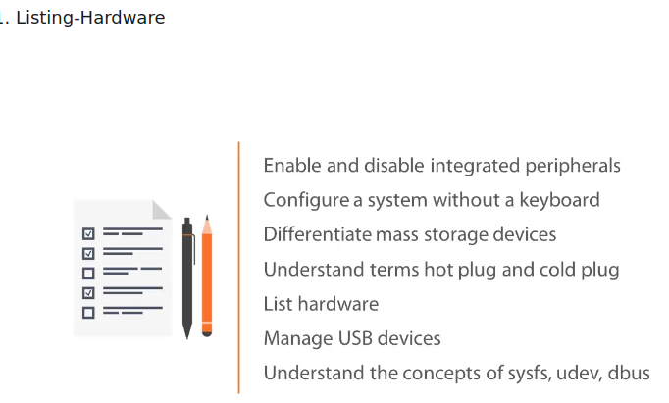

lspci ,lsusb lsblk

Virtual File System: /proc /sys /dev

Demo --> listing hardware on debian 8

1. Using-Commands-to-Identify-Connected-Hardware:

#lsusb

#lsusb -v | less

#lspci -v

#lspci -vv

#lsblk

3. Using-Virtual-File-Systems-to-Identify-Hardware

#ls /proc

#ls /sys

#ls /dev

#man procfs

#cat devices

#cat cmdline

#cat modules

#cd /sys/module/sr_mod/

#ls

#cd parameters/

#cat xa_test

#cd /dev

#ls

#ls /dev/cdrom

#ls -l /dev/cdrom

4.Working-with-USB-Devices:

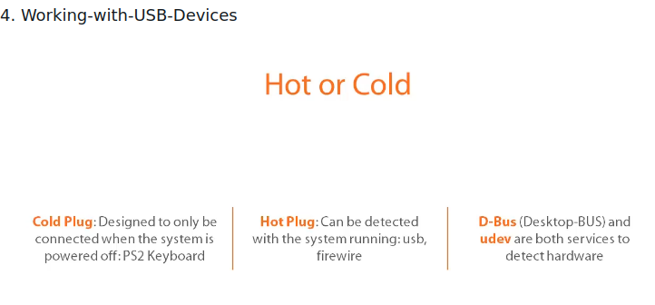

#dmesg

#cat /dev/kmsg

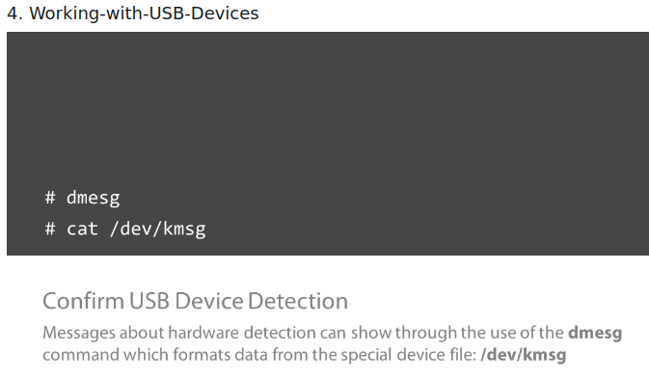

#cd /dev

#lsusb

#lsblk

#ls sd*

#dmesg

#su

#dmesg -C

#dmesg

#lsblk

#ls sd*

dmesg for usb device plug in message

1. Understanding-Kernel-Modules:

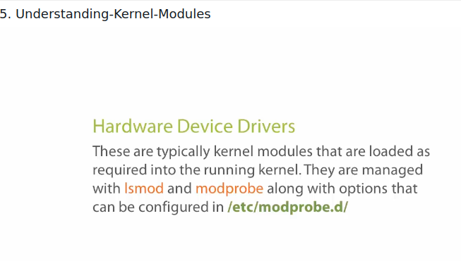

List Loaded Drivers:

#lsmod

lsmod | grep sr_mod

cat /proc/modules

Unloaded Driver

#modprob -r sr_mod

#modprobe -rv sr_mod

load a driver

modeprob sr_modd

modeprobe -v sr_mod

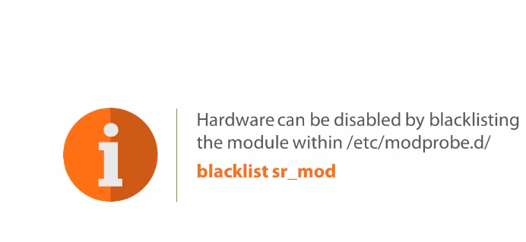

Congiure a system without keyboard:

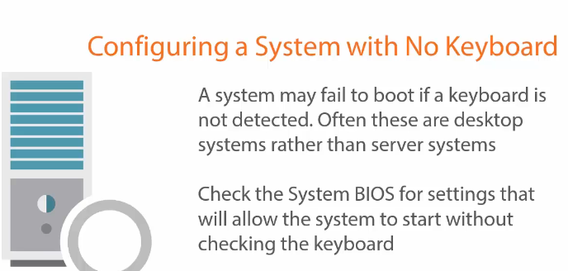

Configure Device Drivers:

1. Loading-and-Unloading-Modules:

cd /dev

#lsmod

#lsmod | grep sr_mod

ctrl l

#modprob -rv sr_mod

#eject /dev/cdrom

#modprobe -rv sr_mod

#modprob -v sr_mod

#modinfo sr_mod | grep parm

7. Stop-Press-Detect-Resources-Used-by-Hardware

#cd /sys

#ls

#cd /devices/